Sheet 2 Assignment 3
Team 11

HuggingFace: https://huggingface.co/azeem23/seqtrack/tree/main/train/seqtrack/seqtrack_b256

Environment used:

Using WSL2 Ubuntu 22.04 LTS
Conda environment Python 3.8
Installing the dependencies in the install.sh bash file, we verified they are correctly installed using conda list.
The used dependencies are provided in installed_packages.txt

Dataset preparation:

Downloaded the two classes (mouse and electricfan) using the following command:

wget https://huggingface.co/datasets/l-lt/LaSOT/resolve/main/mouse.zip
wget https://huggingface.co/datasets/l-lt/LaSOT/resolve/main/electricfan.zip

Sizes of 1.08 GB, 1.5 GB respectively.

Unzipped and moved them to ./data/lasot
Using the following command:

mkdir lasot
mv electricfan.zip mouse.zip lasot/
cd lasot
for z in *.zip; do
unzip -q "$z" -d "${z%.zip}"
rm "$z"
done

Modifications:

seqtrack_b256.yaml file

Removed other datasets Lines 26-33
Reduced SAMPLE_PER_EPOCH to be 100 due to GPU limitations Line 34
Specified Epochs to be 10 Lines 47

config.py file

Specified Epochs to be 10 Lines 33
Reduced SAMPLE_PER_EPOCH to be 100 Line 61
Set the random seed to be team number (11) Line 30

base_trainer.py
Added code for automatic checkpoint upload in the training loop Lines 148-155
api = HfApi(token="")
api.upload_folder(
folder_path="./checkpoints",
repo_id="azeem23/seqtrack",
repo_type="model", # or "model", "space"
commit_message=f"Uploaded checkpoint {self.epoch}"
)

run_training.py
Function run_training() modified default base_seed to be 11. Line 26

Training:

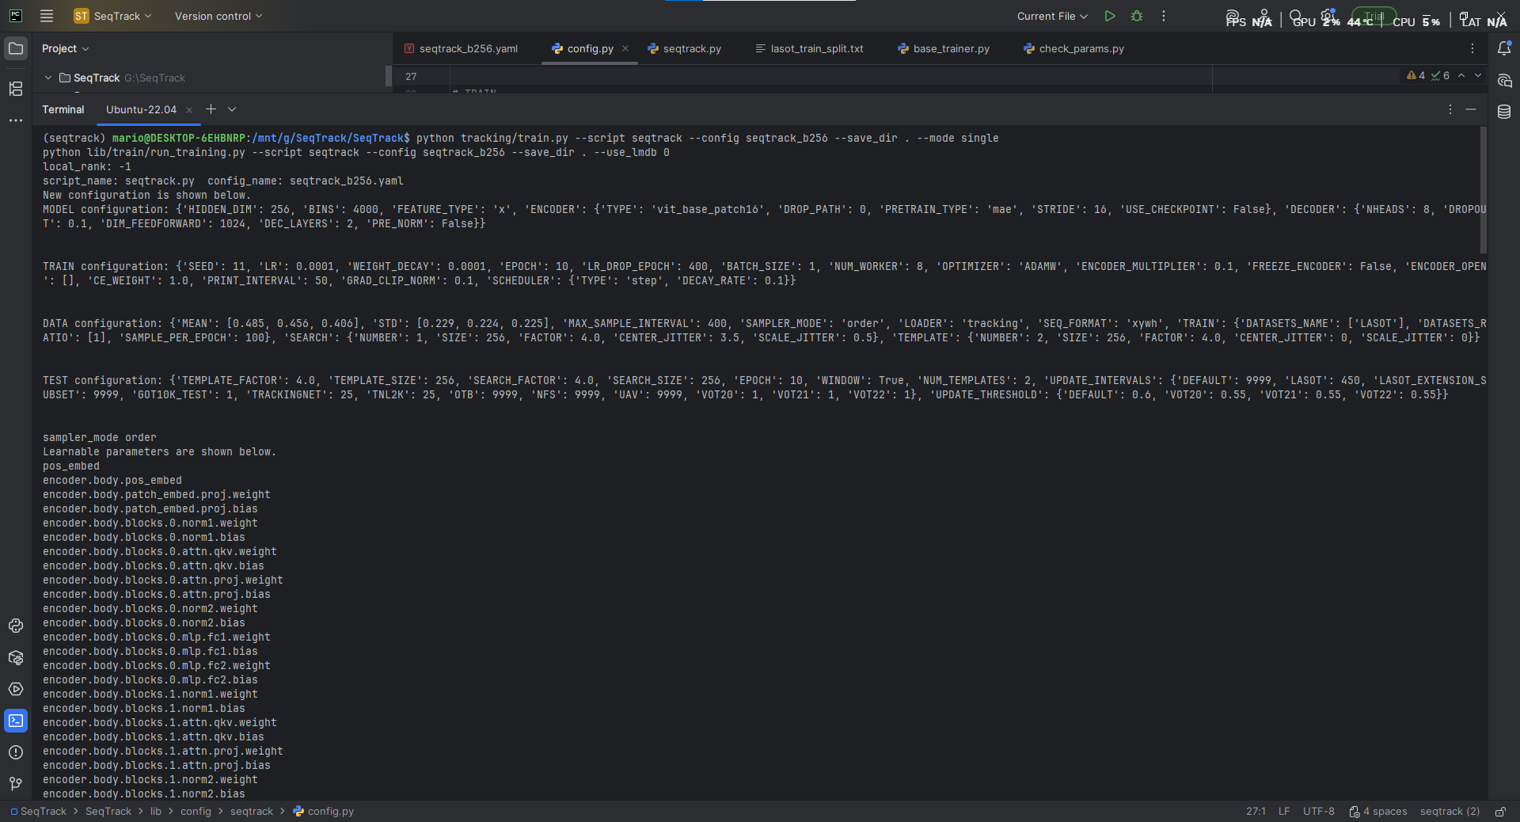
As shown in the screenshot, the seed and number of epochs are loaded correctly.
When running run_training file which calls this function and use fixed seed for the all Random Number Generators:

def init_seeds(seed):
random.seed(seed)
np.random.seed(seed)
torch.manual_seed(seed)
torch.cuda.manual_seed(seed)
torch.backends.cudnn.deterministic = True
torch.backends.cudnn.benchmark = False

During each epoch the checkpoint contains the following:

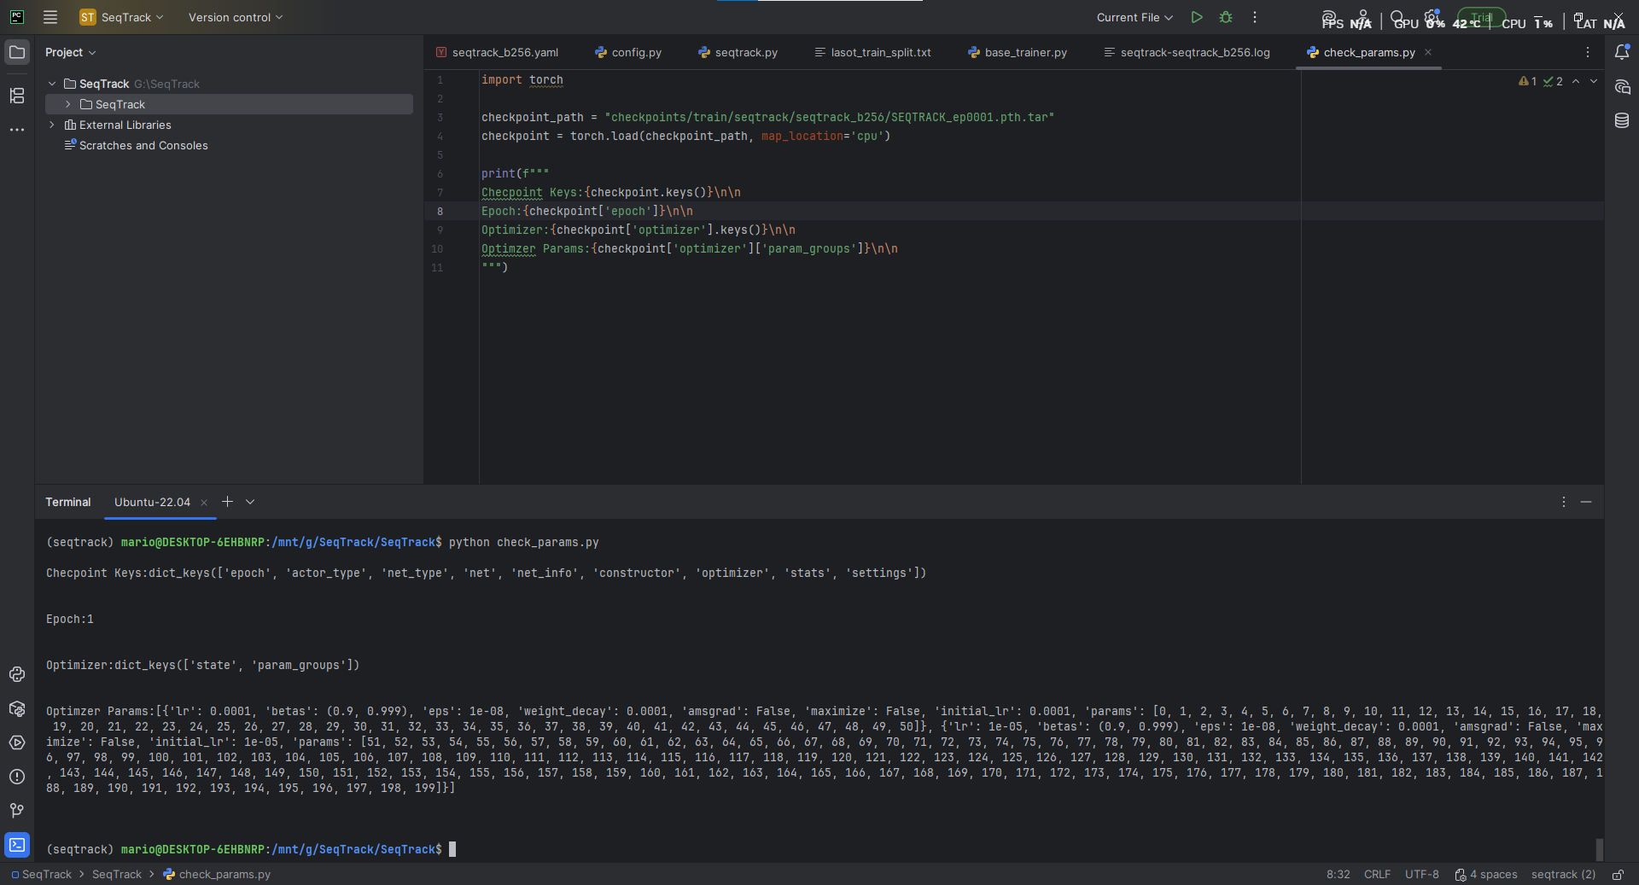

The epoch contains current epoch number information.
The optimizer contains current state and param_groups which contains learning rate scheduler information.

Starting the training and at the end of each epoch, the checkpoints are automatically uploaded to HuggingFace.
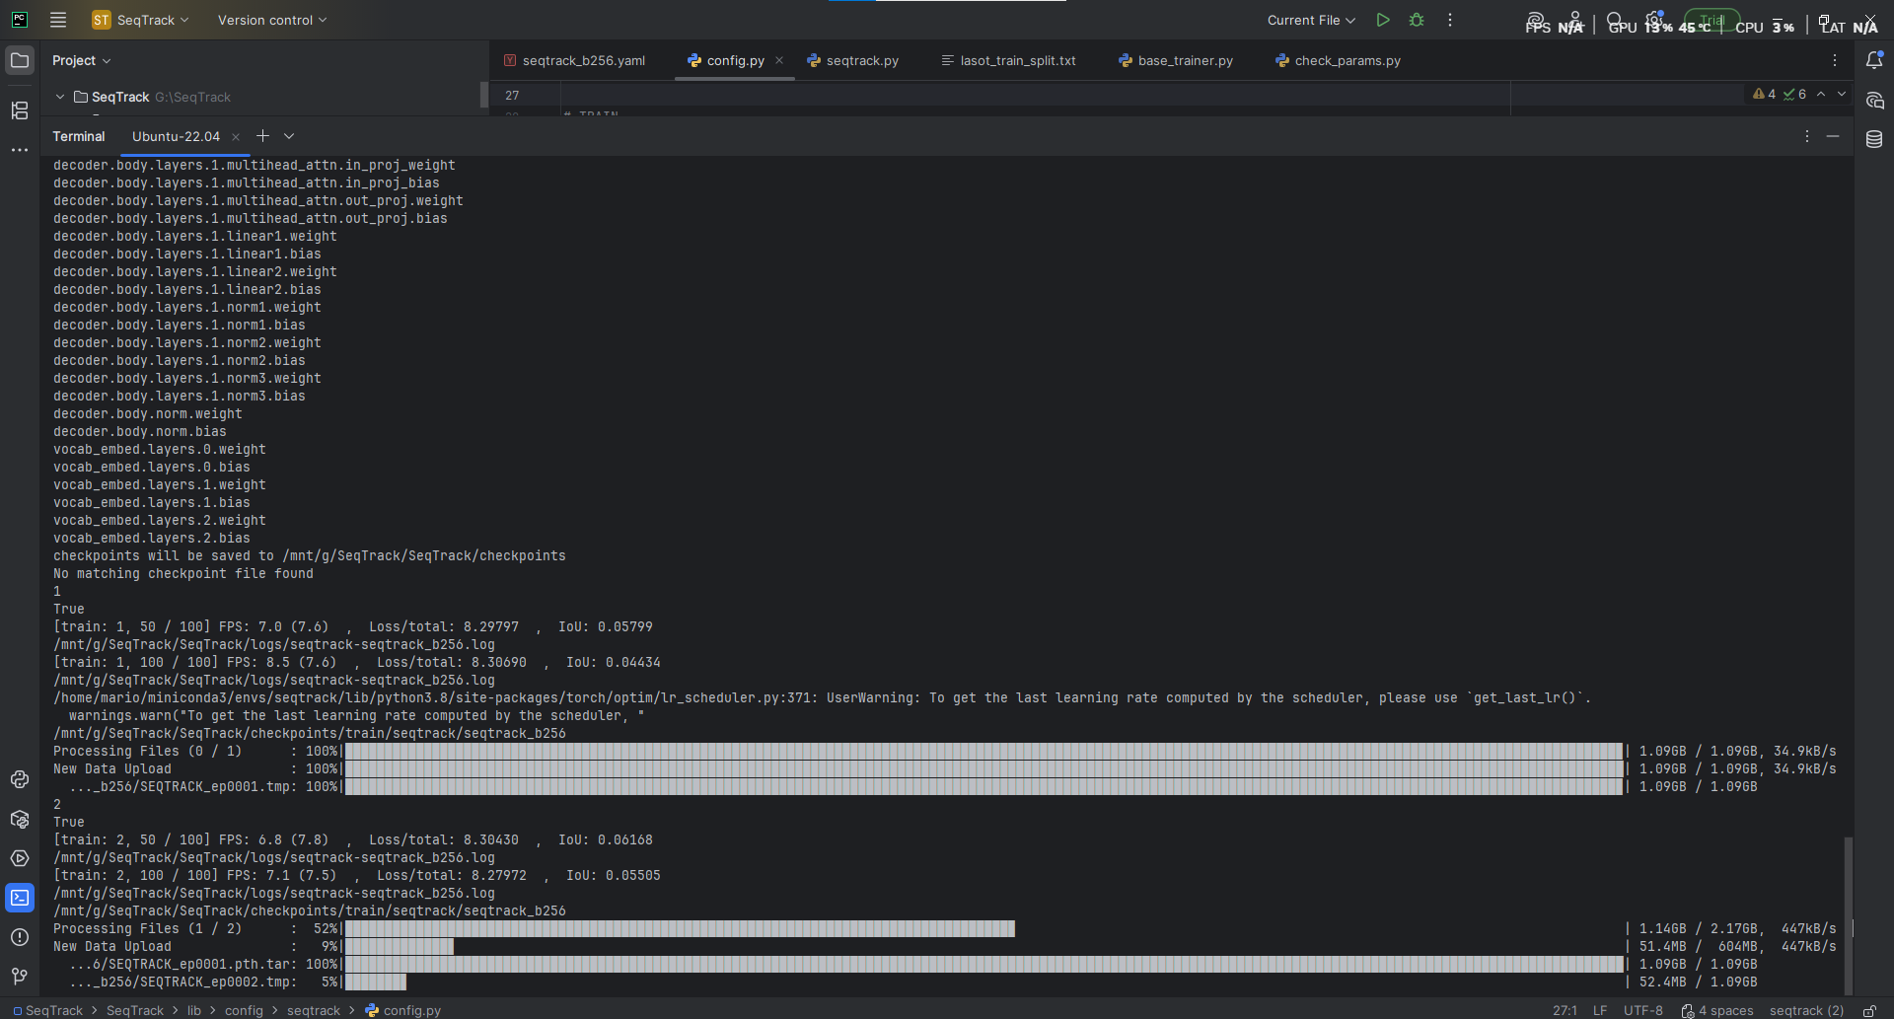

Finished 3 epochs (Phase 1):
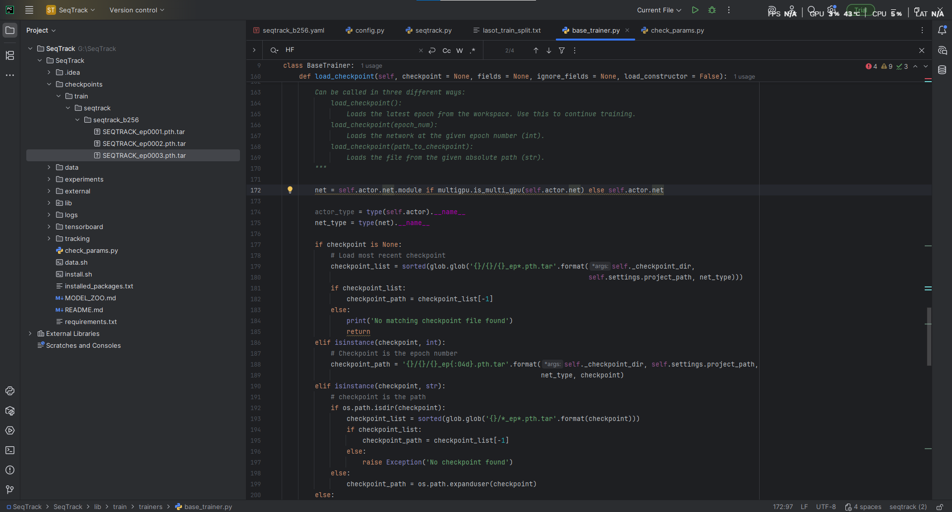

Resumed training from last checkpoint epoch 3 to the end epoch 10 (Phase 2)

Stopped training and the code loaded the parameters again with the same seed and continued from epoch 4.

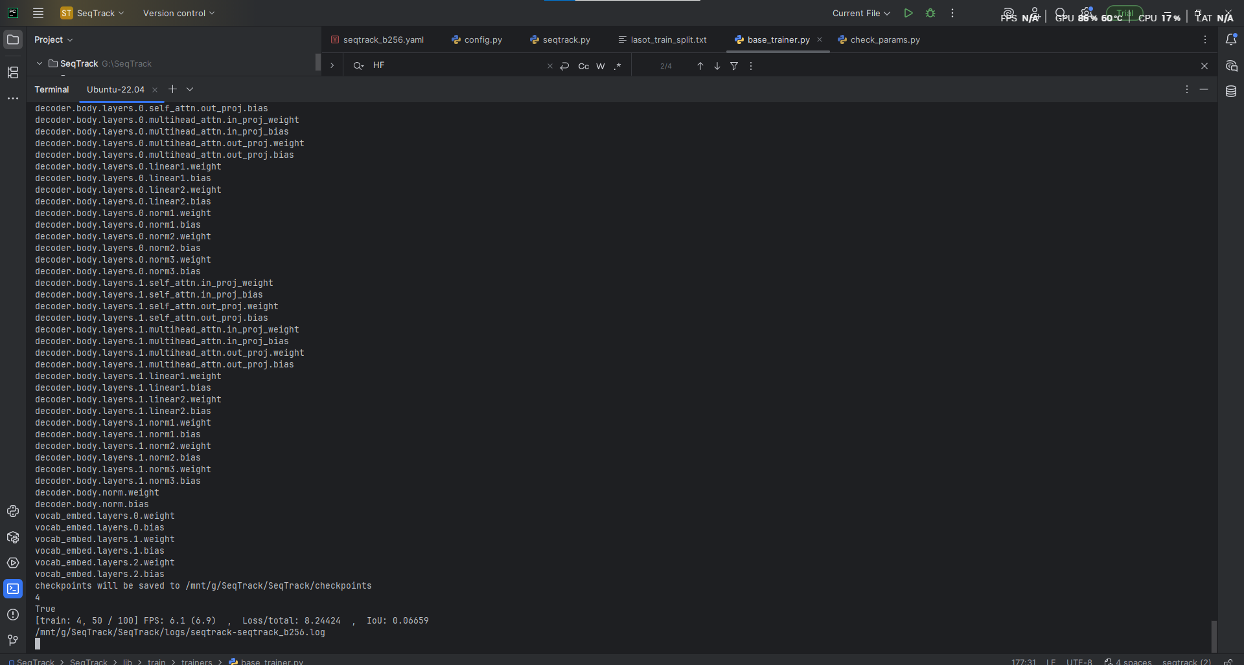

All 10 checkpoints are saved locally and on HuggingFace.
All the logs are saved in the log file with the accuracies and losses:
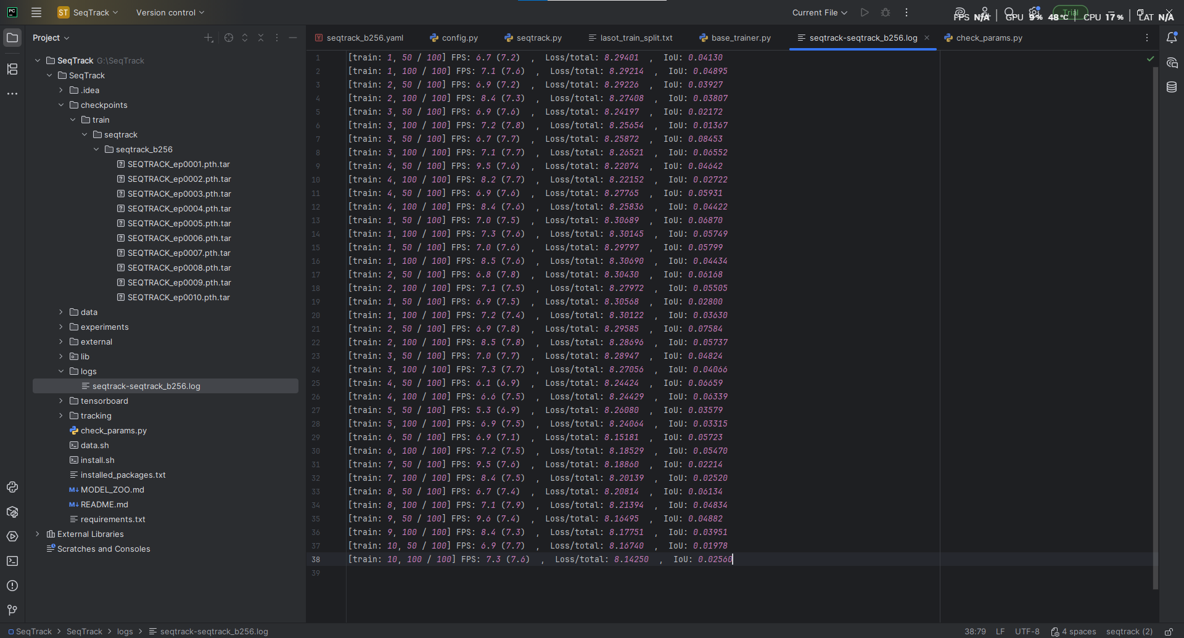

Using tensorboard we can visualize the performance during training

IoU:
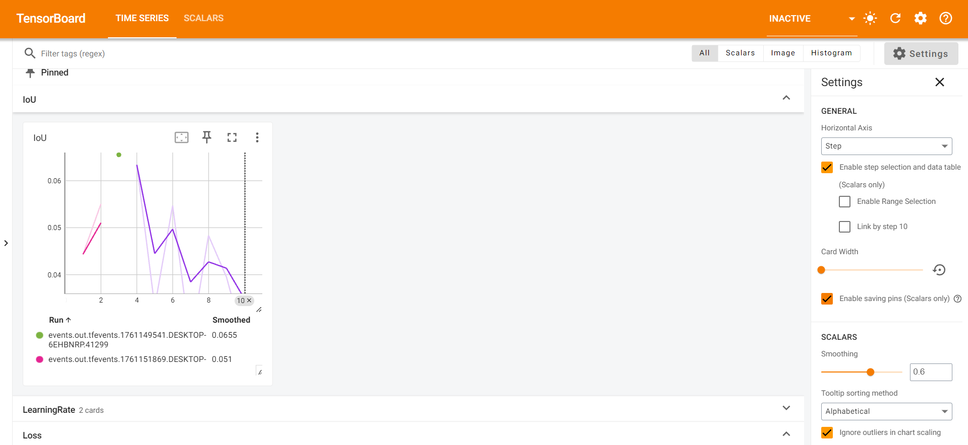

Loss:

